# **Name: Abdurrahman Qureshi**

# **Roll No: 210451**

Practical No: 18

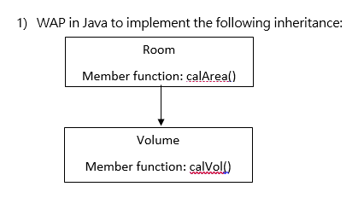

**CODE:**

public class EXP18RoomVol {

public static void main(String[] args) {

Volume V = new Volume();

V.calVol();}}

class Room {

int length = 15;

int breadth = 10;

int area = length * breadth;

protected void calArea() {

System.out.println("Area of the Room is " + area); }}

class Volume extends Room {

protected void calVol() {

int height = 10;

int vol = length * breadth * height;

calArea();

System.out.println("Volume of the Room is " + vol; }}

**OUTPUT:**

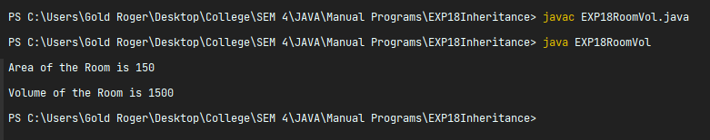

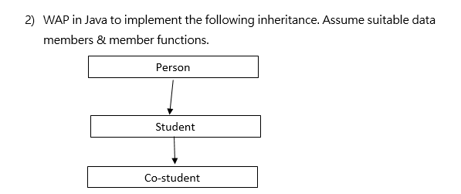**CODE:**

public class EXP18PersonStudCo {

public static void main(String[] args) {

EXP18CoStud C = new EXP18CoStud();

C.CGender();}}

class EXP18Person {

String fName = "Simon";

String lName = "Riley";

protected void PName() {

System.out.println("Full name : \t\t\t" + fName + " " + lName); }}

class EXP18Student extends EXP18Person {

String branch = "Computer Engineering";

protected void SBranch() {

System.out.println("Branch : \t\t\t" + branch); }}

class EXP18CoStud extends EXP18Student{

String gender = "Male";

protected void CGender() {

PName();

SBranch();

System.out.println("Gender : \t\t\t" + gender); }}

**OUTPUT:**

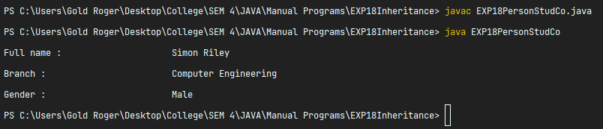

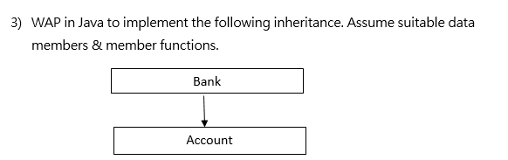**CODE:**

public class EXP18BankAcc {

public static void main(String[] args) {

EXP18Account A = new EXP18Account();

A.AccNumber();}}

class EXP18Bank {

String bName = "Silicon Valley Bank";

protected void BankName() {

System.out.println("Bank Name : \t\t\t" + bName); }}

class EXP18Account extends EXP18Bank {

long accNum = 842695173;

protected void AccNumber() {

BankName();

System.out.println("Account Number : \t\t" + accNum); }}

**OUTPUT:**

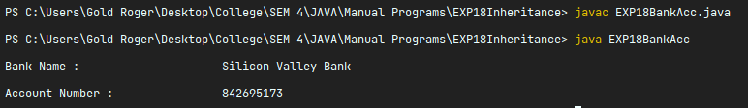

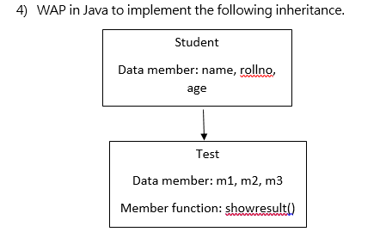

**CODE:**

public class EXP18StudMrks {

public static void main(String[] args) {

Test T = new Test();

T.showResult();}}

class Student {

int rollN = 210451 , age = 18;

String name = "Dawg Qureshi";

protected void SInfo() {

System.out.println("Name : \t\t\t" + name);

System.out.println("Age : \t\t\t" + age);

System.out.println("Roll Number : \t"+ rollN); }}

class Test extends Student {

int m1 = 79,m2 = 83 ,m3 = 88;

int r = (m1+m2+m3)/3;

protected void showResult() {

SInfo();

System.out.println("Result : \t\t" + r); }}

**OUTPUT:**

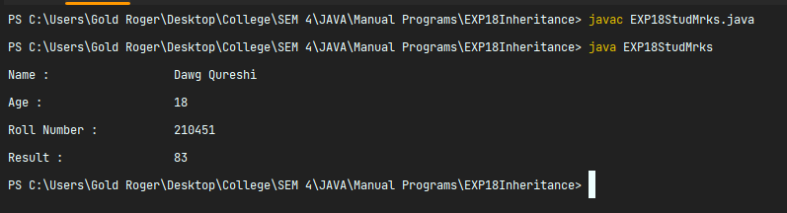

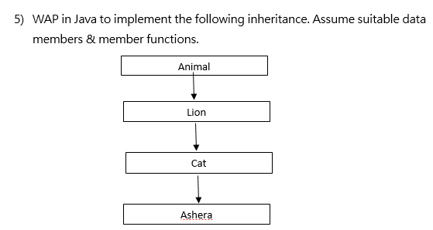**CODE:**

public class EXP18AniLionCatAs {

public static void main(String[] args) {

Ashera A = new Ashera();

A.cName();}}

class Animal {

protected void Type() {

System.out.println("A 4 legged animal \t\t\t\t\t ---> Animal Class");}}

class Lion extends Animal {

protected void Carnivore() {

System.out.println("Belongs to family of lions \t\t\t\t ---> Lion Class");}}

class cat extends Lion {

protected void CATegory() {

System.out.println("Its a white cat \t\t\t\t\t ---> Cat Class");}}

class Ashera extends cat {

protected void cName() {

Type();

Carnivore();

CATegory();

System.out.println("The cats name is Ashera \t\t\t\t ---> Ashera Class");}}

**OUTPUT:**

